ARTISTS of DE STIJL MOVEMENT

Theo van Doesburg

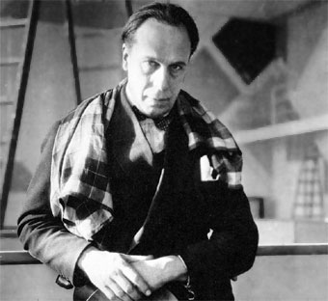

Theo van Doesburg was a Dutch artist, who together with Piet Mondrian established the De Stijl movement. Van Doesburg's most famous work experimented with geometric abstraction and archetypal forms. He was also a prominent architect and writer.

Piet Mondrian

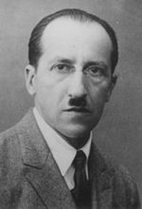

Piet Mondrian, a founding member of the De Stijl movement, was a modern Dutch artist who used grids, perpendicular lines, and the three primary colors in what he deemed Neo-plasticism.

J.J.P. Oud

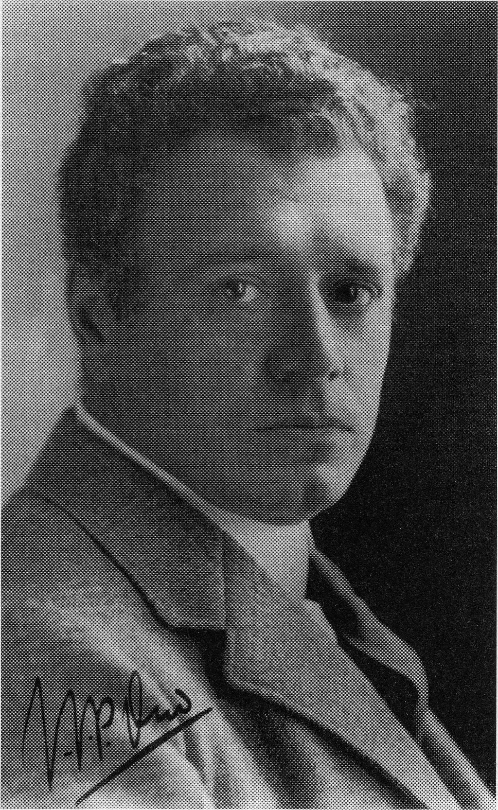

Born Jacobus Johannes Pieter Oud, this Dutch architect was a significant figure in the De Stijl movement. Unlike many of his contemporaries, such as Mies van der Rohe and Le Corbusier, Oud never achieved great fame or money as an architect, and eventually abandoned De Stijl more out of necessity than stylistic differences. His best-known work produced in the De Stijl style is the tiered Gallery House for the Weissenhof Estate (1927) in Stuttgart.

Vilmos Huszár

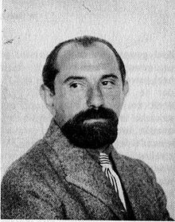

Vilmos Huszár was a Hungarian-Dutch painter and designer, and one of the founding members of the De Stijl movement, along with Theo van Doesburg, Piet Mondrian and others. Very much a disciple of Cubism and Futurism, Huszár's work - especially his painting - can be said to have bridged the gap between these styles and the simple geometric abstraction that's signature to De Stijl. After leaving the movement in 1923, he gained acclaim for his distinctly modern design and packaging for Miss Blanche Virginia Cigarettes.

Ilya Bolotowsky

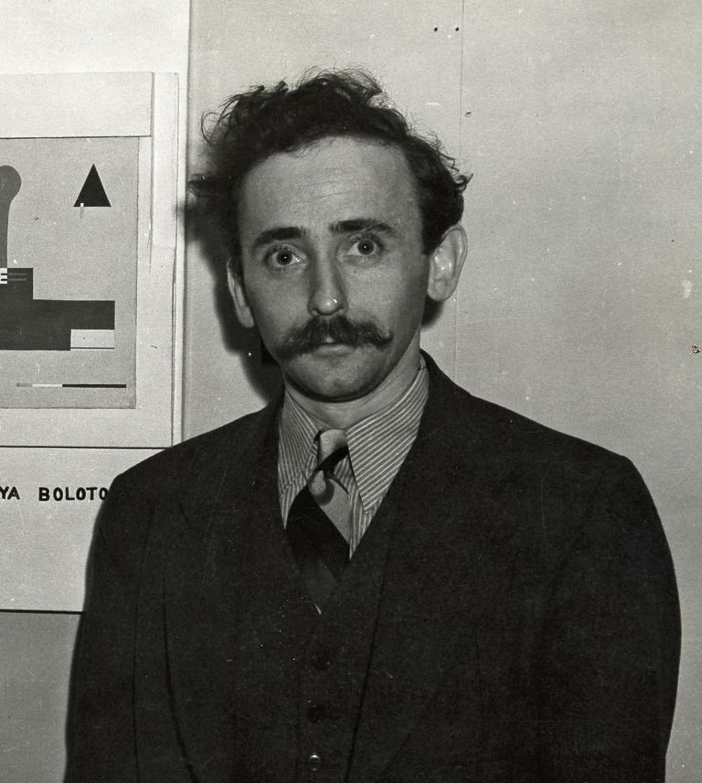

Ilya Bolotowsky was a Russian-born American artist and long-time instructor at Black Mountain College. After immigrating to the U.S. in 1923, he became a member of "The Ten," along with artists Mark Rothko and Adolph Gottlieb, and later on was a founding member of the American Abstract Artists. His work contributed greatly to the styles of Neo-Plasticism and Geometric Abstraction.

