ART of THE DE STIJL MOVEMENT

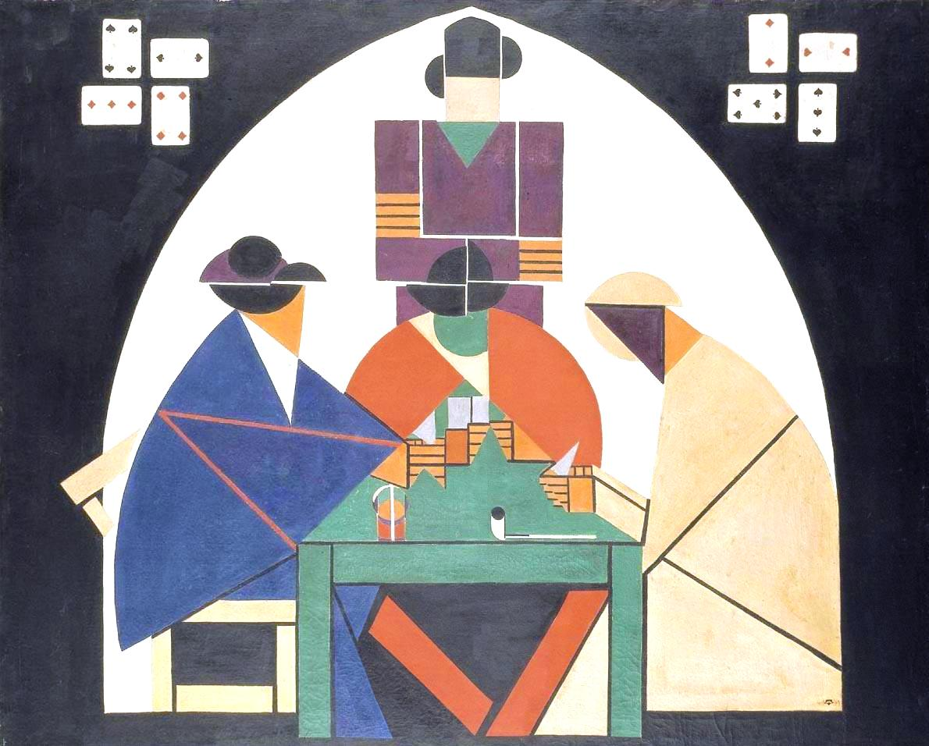
Theo van Doesburg
Card Players
1916-1917

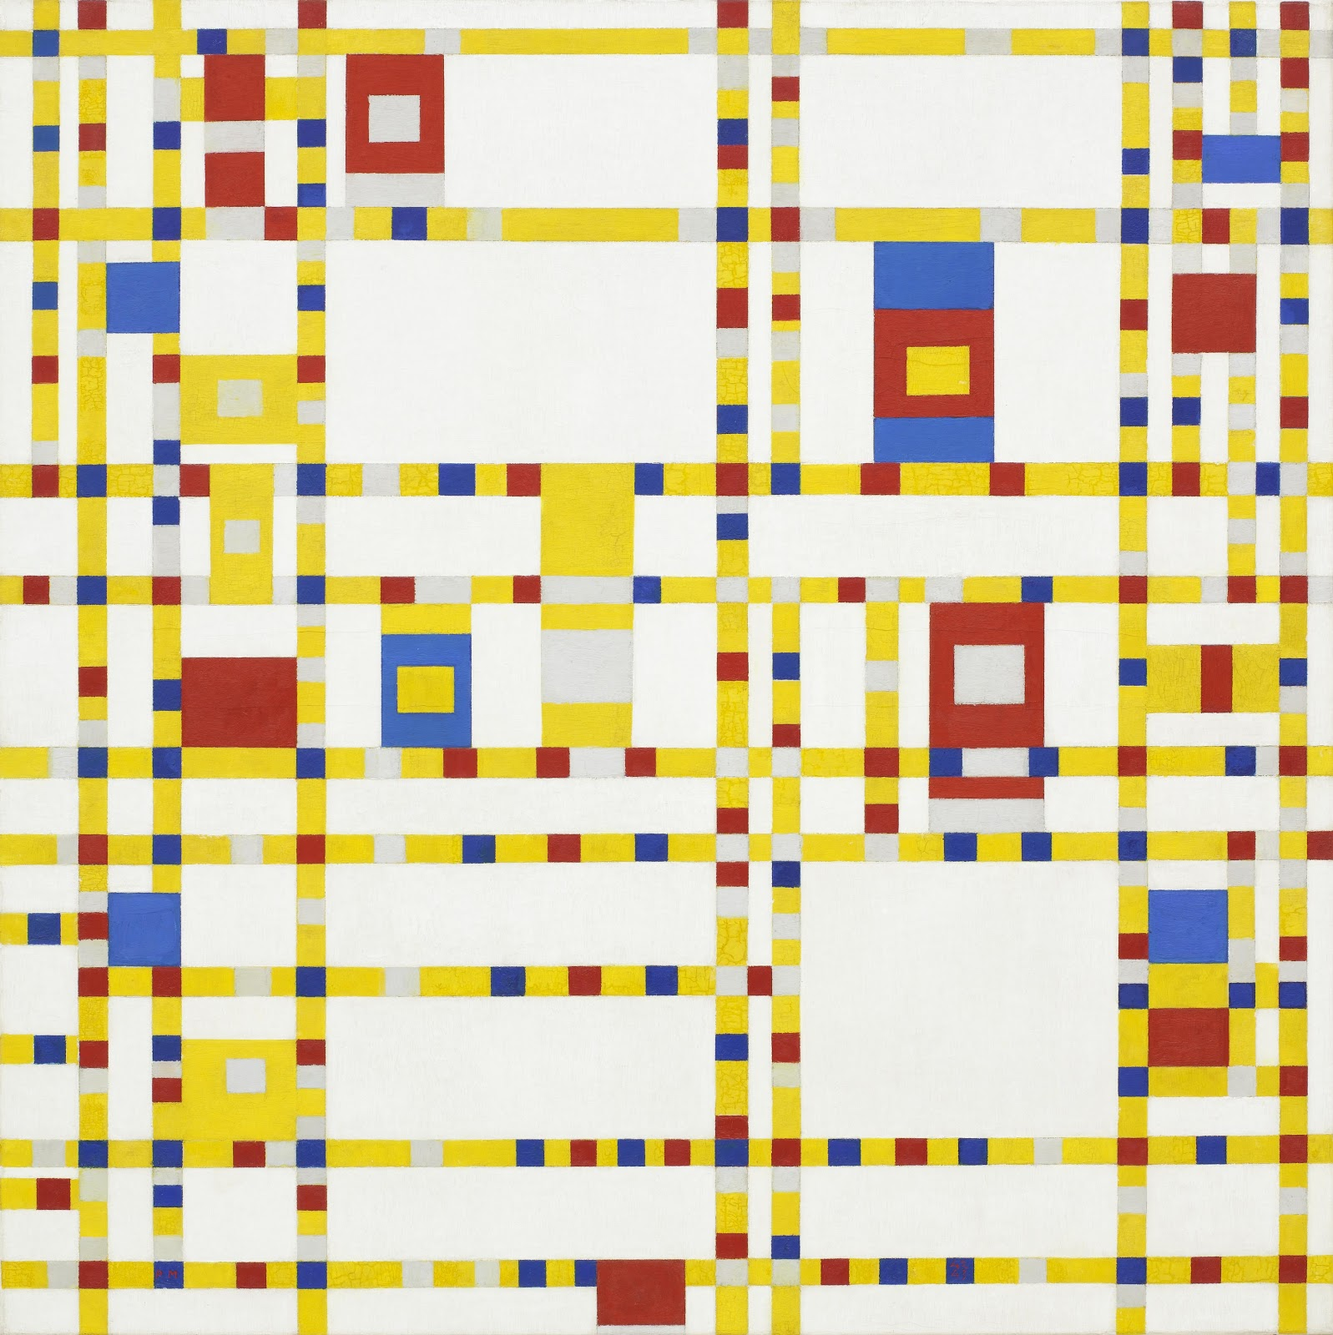
Piet Mondrian
Broadway Boogie-Woogie
1942-1943

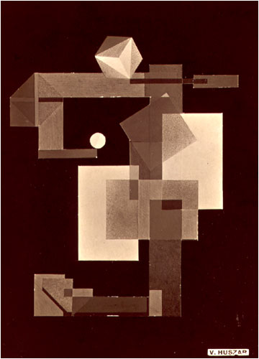
Vilmos Huszar
Mechano-Dancer
1922

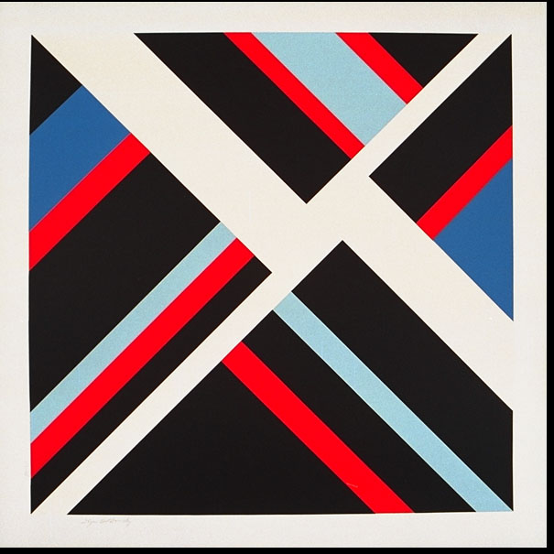
Ilya Bolotowsky
Black Diamond
1978

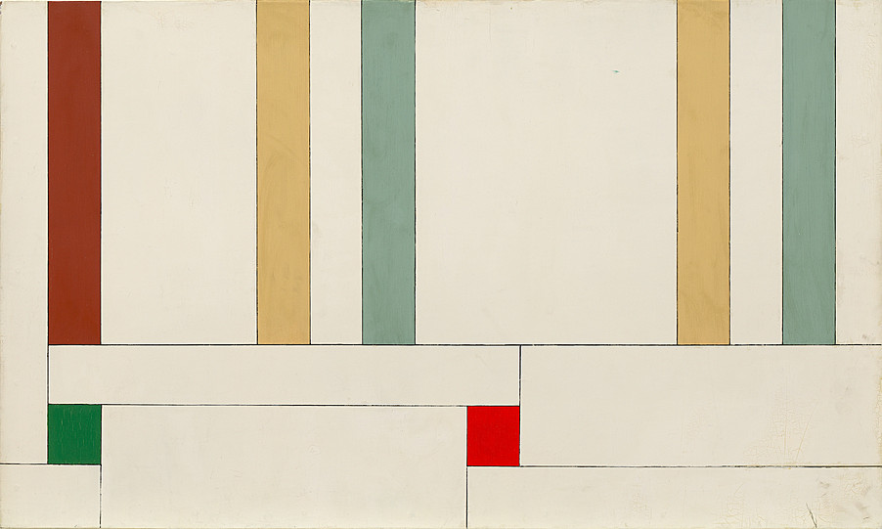
Georges Vantongerloo
Composition 13478/ 15
1937

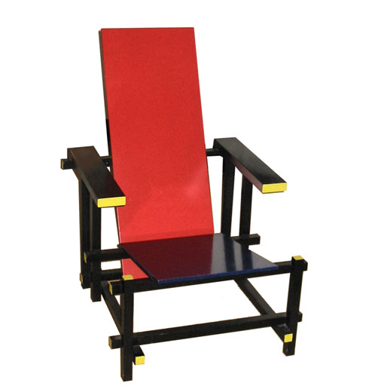
Gerrit Rietveld
Red and Blue Chair
1917

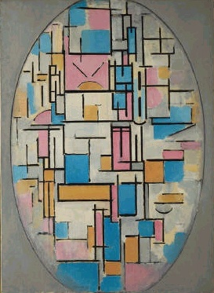

Piet Mondrian
Color Planes in Oval
1913-14

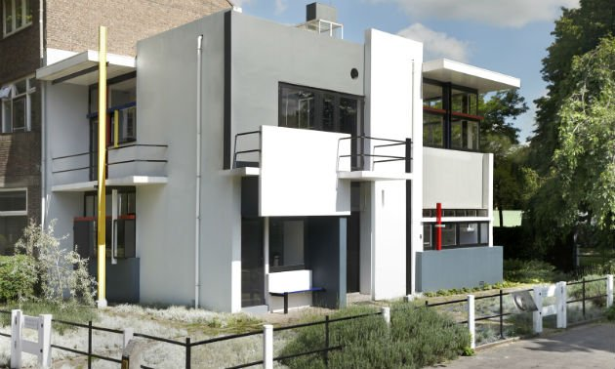
Gerrit T. Rietveld
Schroder House
1924-25

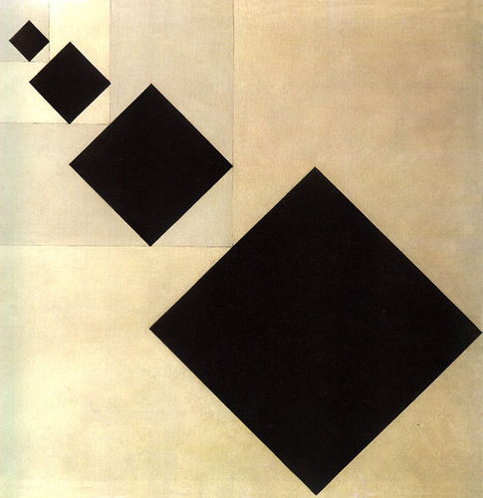
Theo van Doesburg
Arithmetic Composition
1929-30

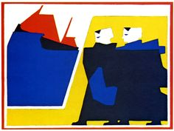
Bart Van der Leck
The Storm
1916

